FILE OPERATIONS
- Write a C program to create a new file using the open() system call. What flags and permissions are required?
PROGRAM:
/*
Program to open a file
Author : MUTHUGANESH S
Date : 01/02/2026
Filename : Open.c
*/

#include <stdio.h>
#include <fcntl.h>
#include <unistd.h>

int main() {

int fd = open("file.txt", O_CREAT | O_WRONLY, 0644);

//O_CREAT → create file if not present
//O_WRONLY → write only

if(fd == -1) {
perror("open");
return 1;
}

printf("File created\n");
close(fd);
}

OUTPUT:
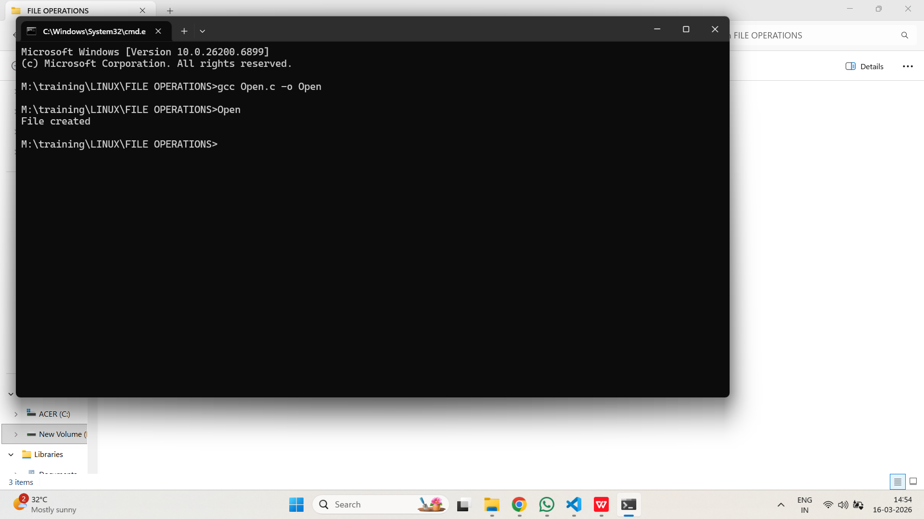
- Implement a program that writes "Hello, Linux!" to a file using write(). How do you handle errors?
PROGRAM:
/*
Program to illustarte write()
Author : MUTHUGANESH S
Date : 01/02/2026
Filename : Write.c
*/

//Header files
#include <stdio.h>
#include <fcntl.h>
#include <unistd.h>

int main() {

int fd = open("hello.txt", O_CREAT | O_WRONLY, 0644);

if(fd < 0) {
perror("open");
return 1;
}

char msg[] = "Hello, Linux!\n";

if(write(fd, msg, sizeof(msg)) < 0) {
perror("write");
}

close(fd);
}

OUTPUT:
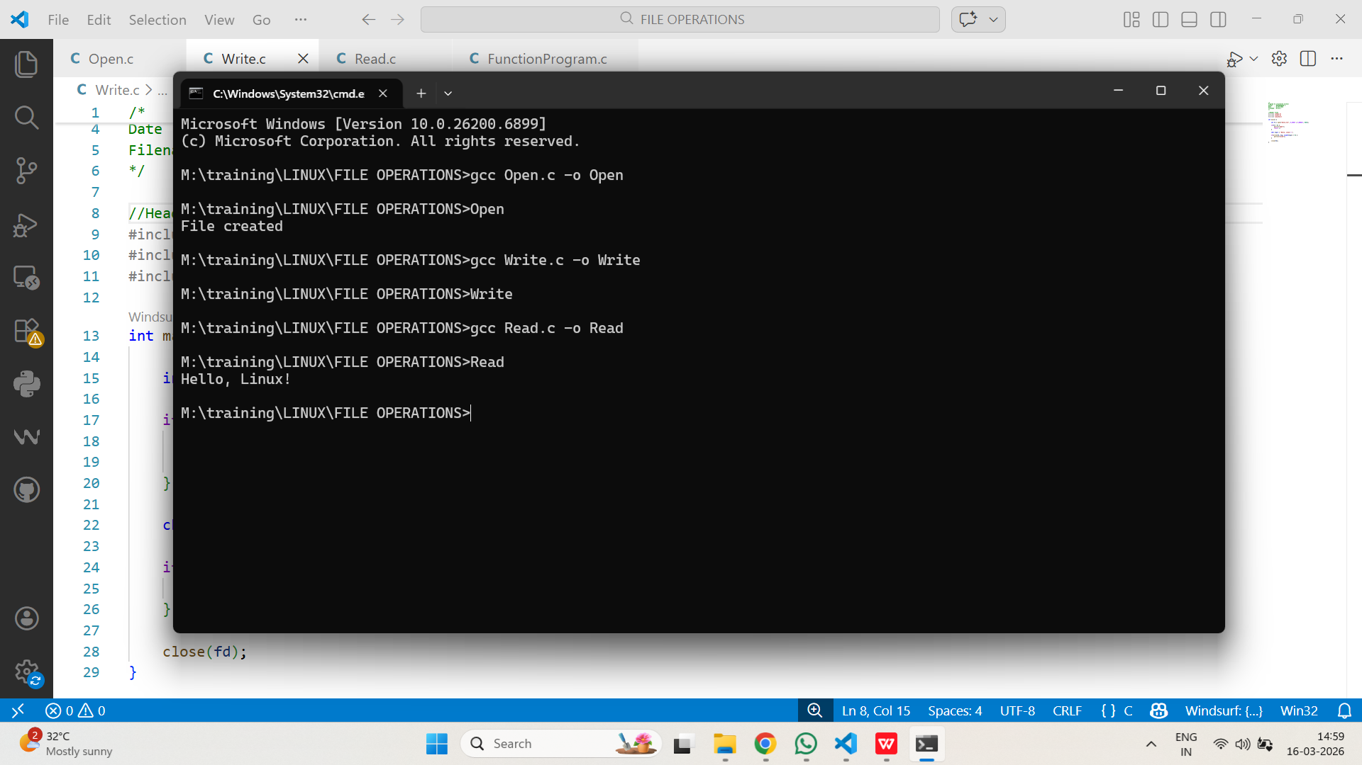

- Write a C program to read the contents of a file using read() and display it on the console
PROGRAM:
/*
Program to read a file
Author : MUTHUGANESH S
Date : 01/02/2026
Filename : Read.c
*/

//Header files
#include <stdio.h>
#include <fcntl.h>
#include <unistd.h>

int main() {

char buffer[100];
int fd = open("hello.txt", O_RDONLY);

int n = read(fd, buffer, sizeof(buffer));

write(1, buffer, n);

close(fd);
}
OUTPUT:

- Demonstrate how to use lseek() to move the file pointer to the beginning, middle, and end of a file.
PROGRAM:
/*
Program to illustarte lseek()
Author : MUTHUGANESH S
Date : 01/02/2026
Filename : lseek.c
*/

//Header files
#include <fcntl.h>
#include <unistd.h>

int main(){

int fd=open("hello.txt",O_RDONLY);

lseek(fd,0,SEEK_SET);//start of file
lseek(fd,5,SEEK_SET);//5th byte
lseek(fd,0,SEEK_END);//end of file

close(fd);
}
OUTPUT:
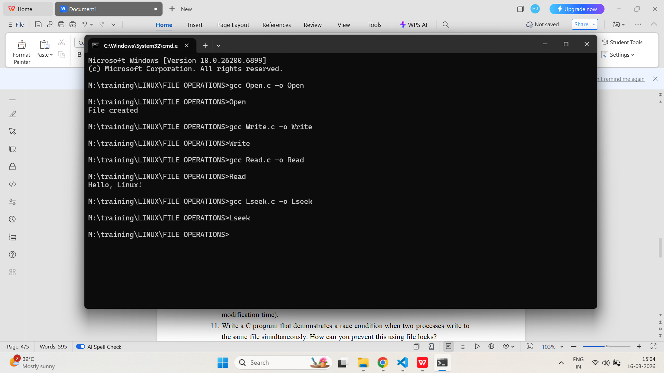
- Write a program to copy the contents of one file to another using only system calls (open, read, write, close).
PROGRAM:
/*
Program to copy using System calls
Author : MUTHUGANESH S
Date : 02/02/2026
Filename : Copy.c
*/

//Header files
#include <fcntl.h>
#include <unistd.h>

int main(){

char buf[1024];

int src=open("a.txt",O_RDONLY);
int dest=open("b.txt",O_CREAT|O_WRONLY,0644);

int n;

while((n=read(src,buf,sizeof(buf)))>0)
write(dest,buf,n);

close(src);
close(dest);
}
OUTPUT:
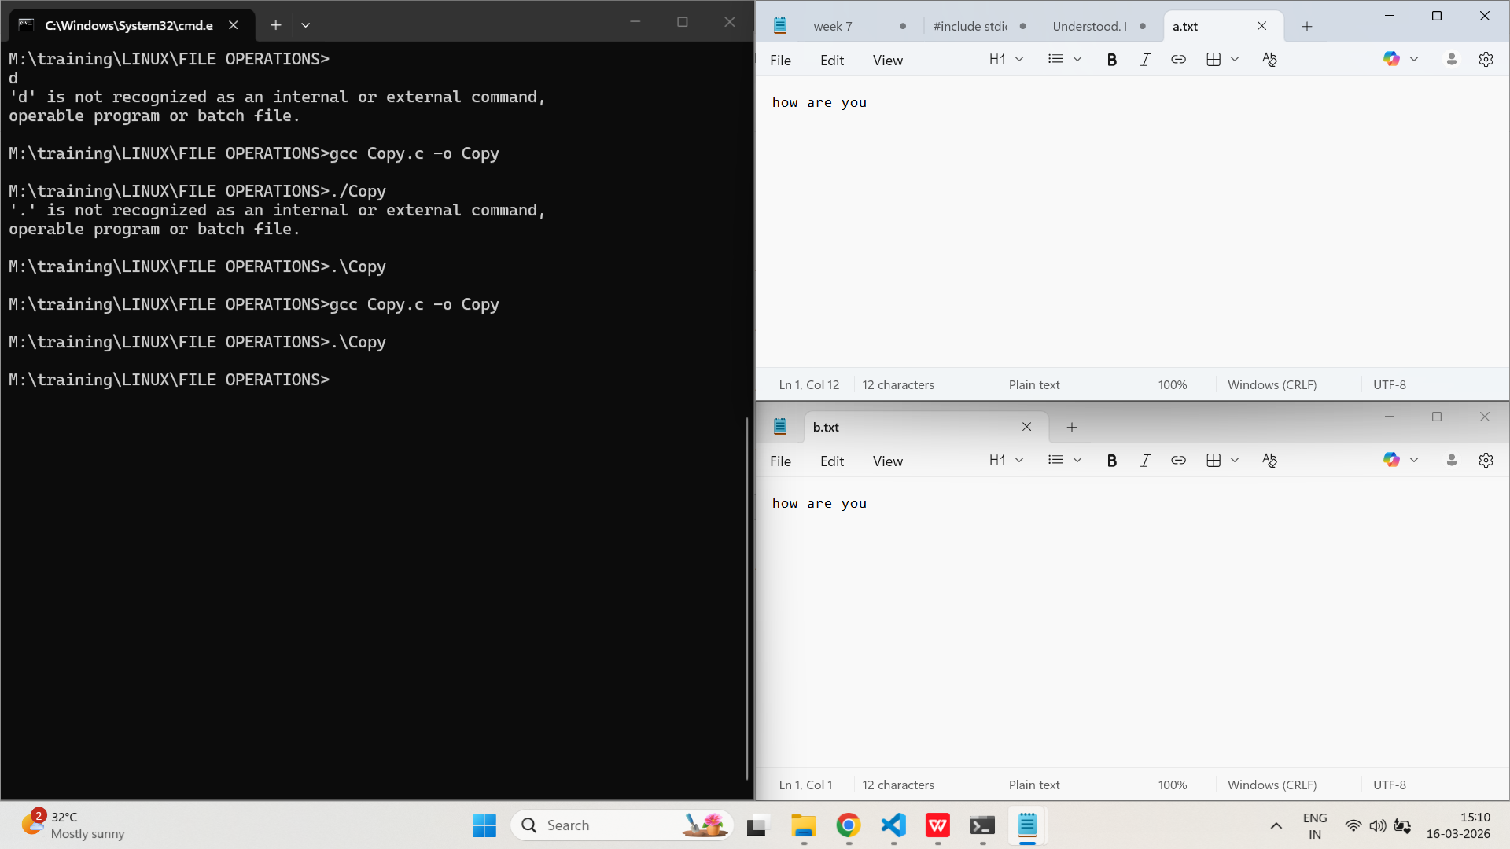
- Show how to change the permissions of a file using the chmod() system call.
PROGRAM:
/*
Program change permision
Author : MUTHUGANESH S
Date : 02/02/2026
Filename : Perm.c
*/

//Header files
#include <sys/stat.h>

int main(){

//change permision
chmod("file.txt",0777);

}
OUTPUT:
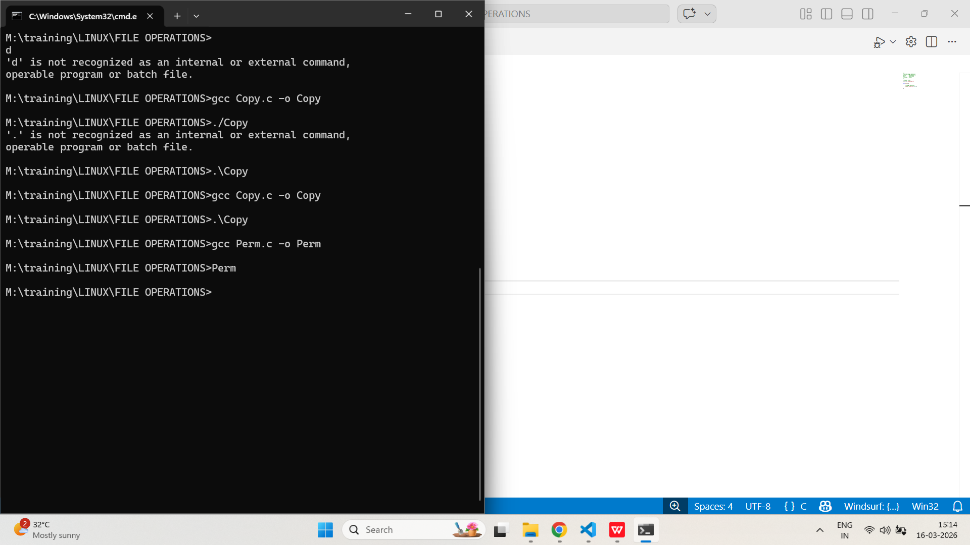
- Write a C program to delete a file using the unlink() system call.
PROGRAM:
/*
Program to delete a file using System calls
Author : MUTHUGANESH S
Date : 02/02/2026
Filename : Del.c
*/

//Header files
#include <unistd.h>

int main(){

//delete file
unlink("file.txt");

}
OUTPUT:
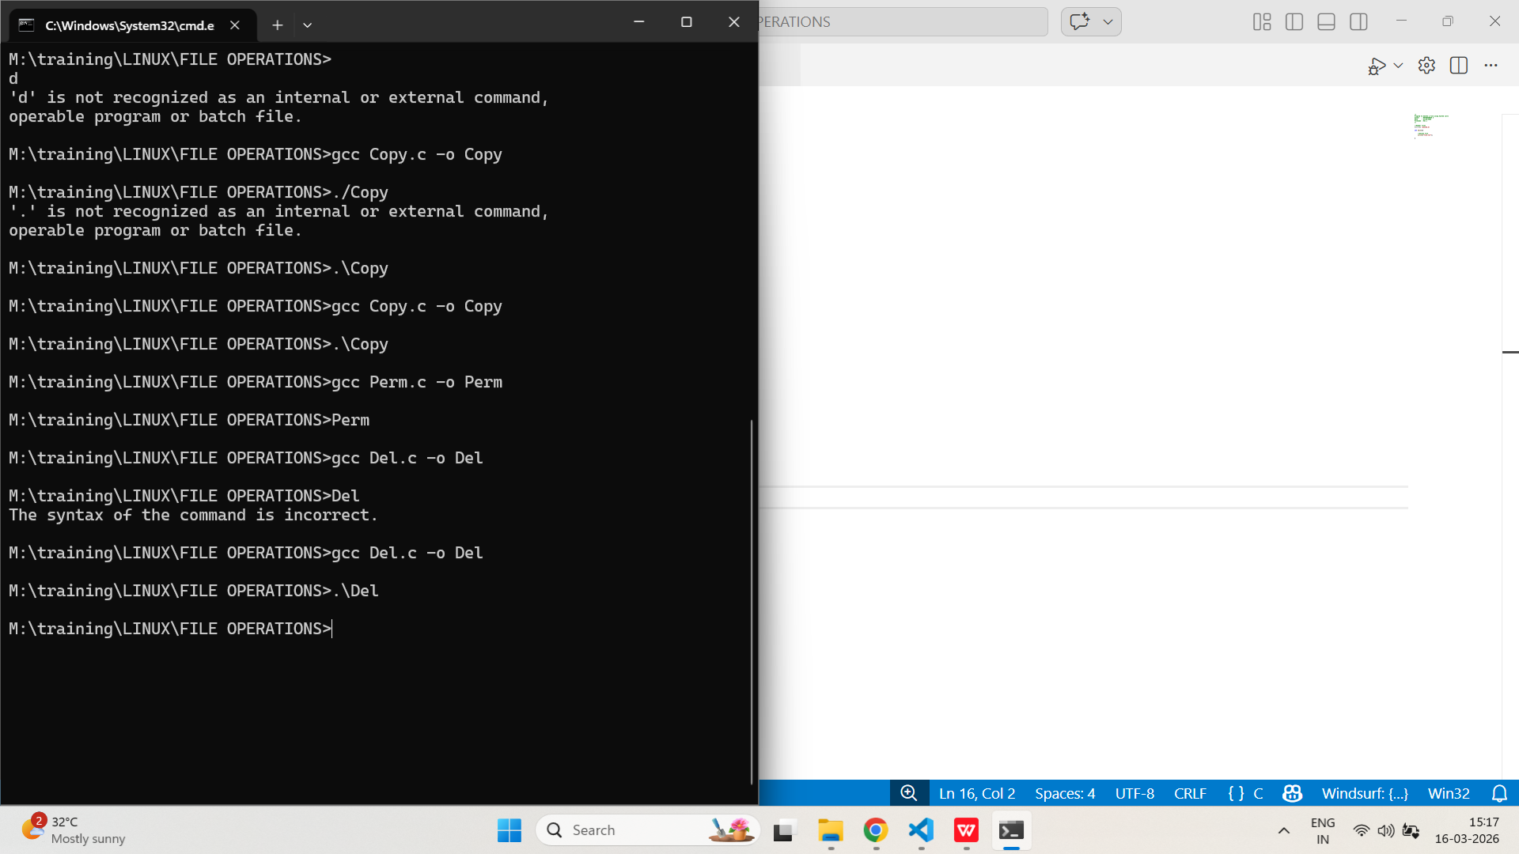
- Implement a program that creates a directory using mkdir() and removes it using rmdir().
PROGRAM:
/*
Program to Create and remove directory using System calls
Author : MUTHUGANESH S
Date : 02/02/2026
Filename : Dir.c
*/

#include <stdio.h>
#include <direct.h>

int main(){

mkdir("testdir");

rmdir("testdir");

return 0;
}
OUTPUT:
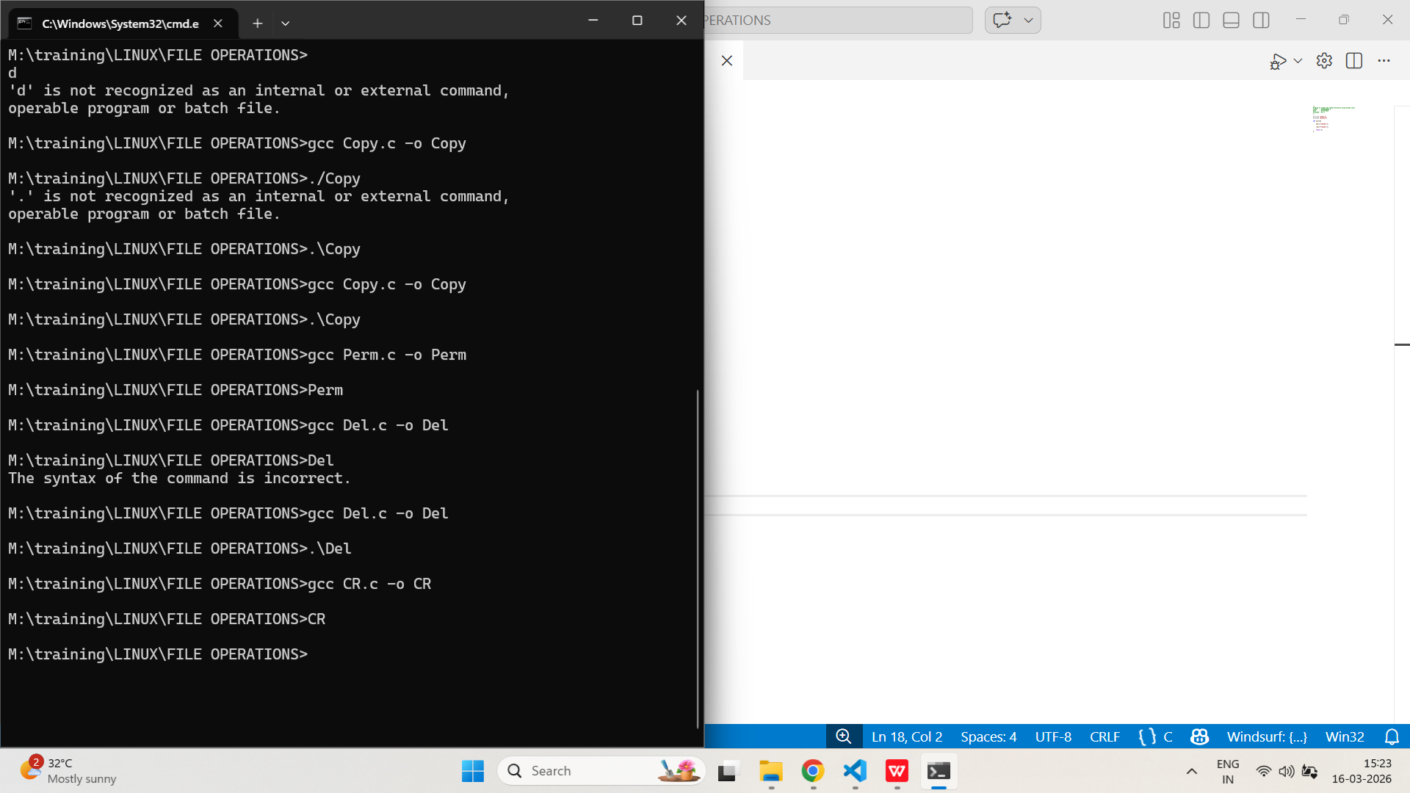
- Write a program to list all files in a directory using opendir(), readdir(), and closedir().
PROGRAM:
/*
Program to list directory using System calls
Author : MUTHUGANESH S
Date : 02/02/2026
Filename : Dir.c
*/

//Header files
#include <dirent.h>
#include <stdio.h>

int main(){

//open directory
DIR *d=opendir(".");

//d is a pointer to directory
struct dirent *dir;

while((dir=readdir(d))!=NULL)
printf("%s\n",dir->d_name);

//close directory
closedir(d);

}
OUTPUT:
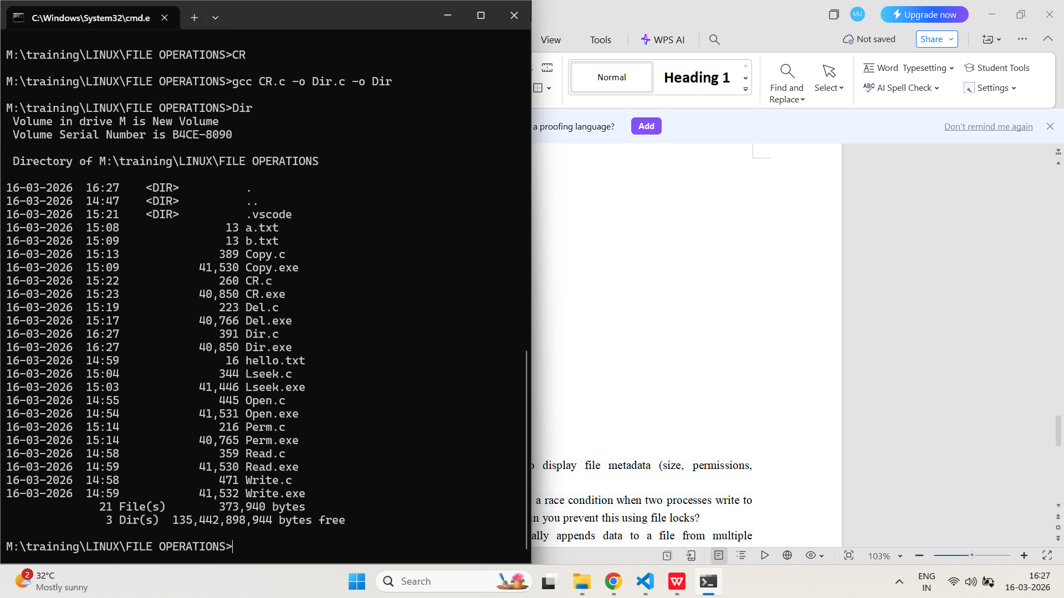
- Demonstrate how to use stat() to display file metadata (size, permissions, modification time).
PROGRAM:
/*
Program to get size and permissions of a file
Author : MUTHUGANESH S
Date : 03/02/2026
Filename : stat.c
*/

//Header files
#include <sys/stat.h>
#include <stdio.h>

int main(){

struct stat s;

//get size and permissions
stat("file.txt",&s);

printf("Size:%ld\n",s.st_size);
printf("Permissions:%o\n",s.st_mode);

}
OUTPUT:
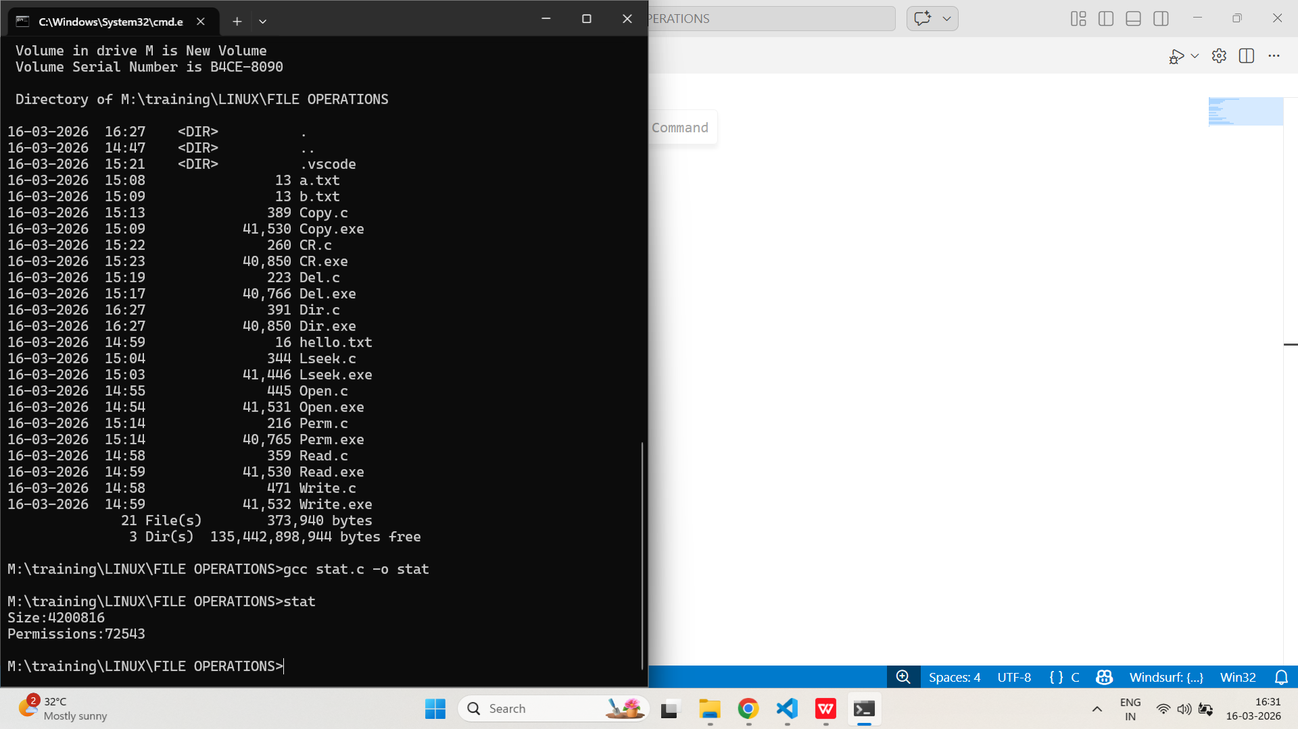
- Write a C program that demonstrates a race condition when two processes write to the same file simultaneously. How can you prevent this using file locks?
PROGRAM:
/*
Program to demonstrate race condition
Author : MUTHUGANESH S
Date : 03/02/2026
Filename : race.c
*/

//Header files
#include <stdio.h>
#include <unistd.h>
#include <fcntl.h>
#include <stdlib.h>
#include <string.h>

int main()
{
int fd = open("shared.txt", O_WRONLY | O_CREAT | O_APPEND, 0644);

if(fd < 0)
{
perror("open");
exit(1);
}

pid_t pid = fork();

for(int i = 0; i < 10; i++)
{
if(pid == 0)
{
write(fd, "Child writing\n", 14);
}
else
{
write(fd, "Parent writing\n", 15);
}

usleep(100000);
}

close(fd);
}
/*
Program to implement file locking
Author : MUTHUGANESH S
Date : 03/02/2026
Filename : lock.c
*/

#include <stdio.h>
#include <unistd.h>
#include <fcntl.h>
#include <stdlib.h>
#include <string.h>

void lock_file(int fd)
{
struct flock lock;

lock.l_type = F_WRLCK;
lock.l_whence = SEEK_SET;
lock.l_start = 0;
lock.l_len = 0;

fcntl(fd, F_SETLKW, &lock);
}

void unlock_file(int fd)
{
struct flock lock;

lock.l_type = F_UNLCK;
lock.l_whence = SEEK_SET;
lock.l_start = 0;
lock.l_len = 0;

fcntl(fd, F_SETLK, &lock);
}

int main()
{
int fd = open("shared.txt", O_WRONLY | O_CREAT | O_APPEND, 0644);

if(fd < 0)
{
perror("open");
exit(1);
}

pid_t pid = fork();

for(int i = 0; i < 10; i++)
{
lock_file(fd);

if(pid == 0)
{
write(fd, "Child writing\n", 14);
}
else
{
write(fd, "Parent writing\n", 15);
}

unlock_file(fd);

usleep(100000);
}

close(fd);
}
OUTPUT:
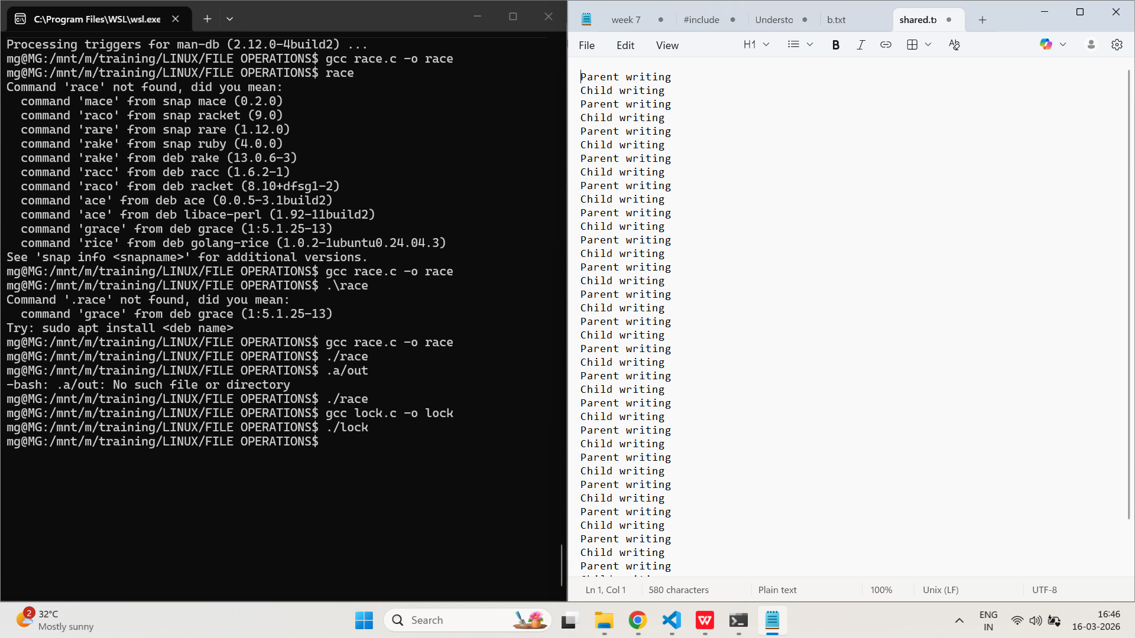
- Implement a program that atomically appends data to a file from multiple processes. Explain how you ensure atomicity.
PROGRAM:
/*
Program to implement atomic write
Author : MUTHUGANESH S
Date : 03/02/2026
Filename : atomic.c
*/

//Header files
#include <stdio.h>
#include <unistd.h>
#include <fcntl.h>
#include <stdlib.h>
#include <string.h>

int main()
{
int fd = open("atomic.txt", O_WRONLY | O_CREAT | O_APPEND, 0644);

if(fd < 0)
{
perror("open");
exit(1);
}

pid_t pid = fork();

for(int i = 0; i < 10; i++)
{
char buffer[50];

if(pid == 0)
{
sprintf(buffer, "Child process writing %d\n", i);
}
else
{
sprintf(buffer, "Parent process writing %d\n", i);
}

write(fd, buffer, strlen(buffer));

sleep(1);
}

close(fd);
return 0;
}
OUTPUT:
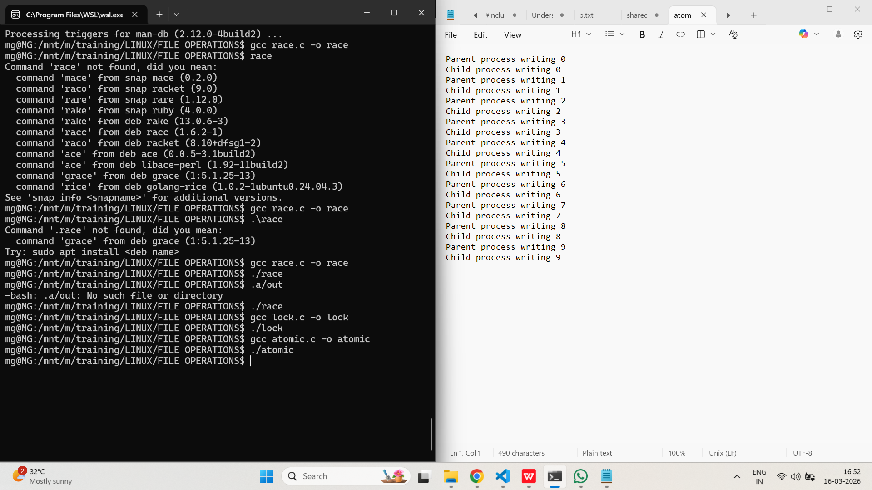
- Use lseek() to create a sparse file. Show how to verify the file’s actual disk usage versus its reported size.
PROGRAM:
/*
Program to create a sparse file
Author : MUTHUGANESH S
Date : 04/02/2026
Filename : sparse.c
*/

//Header files
#include <fcntl.h>
#include <unistd.h>

int main(){

//Creating a sparse file
int fd=open("sparse.txt",O_CREAT|O_WRONLY,0644);

lseek(fd,10000,SEEK_SET);

write(fd,"A",1);

close(fd);
}
OUTPUT:
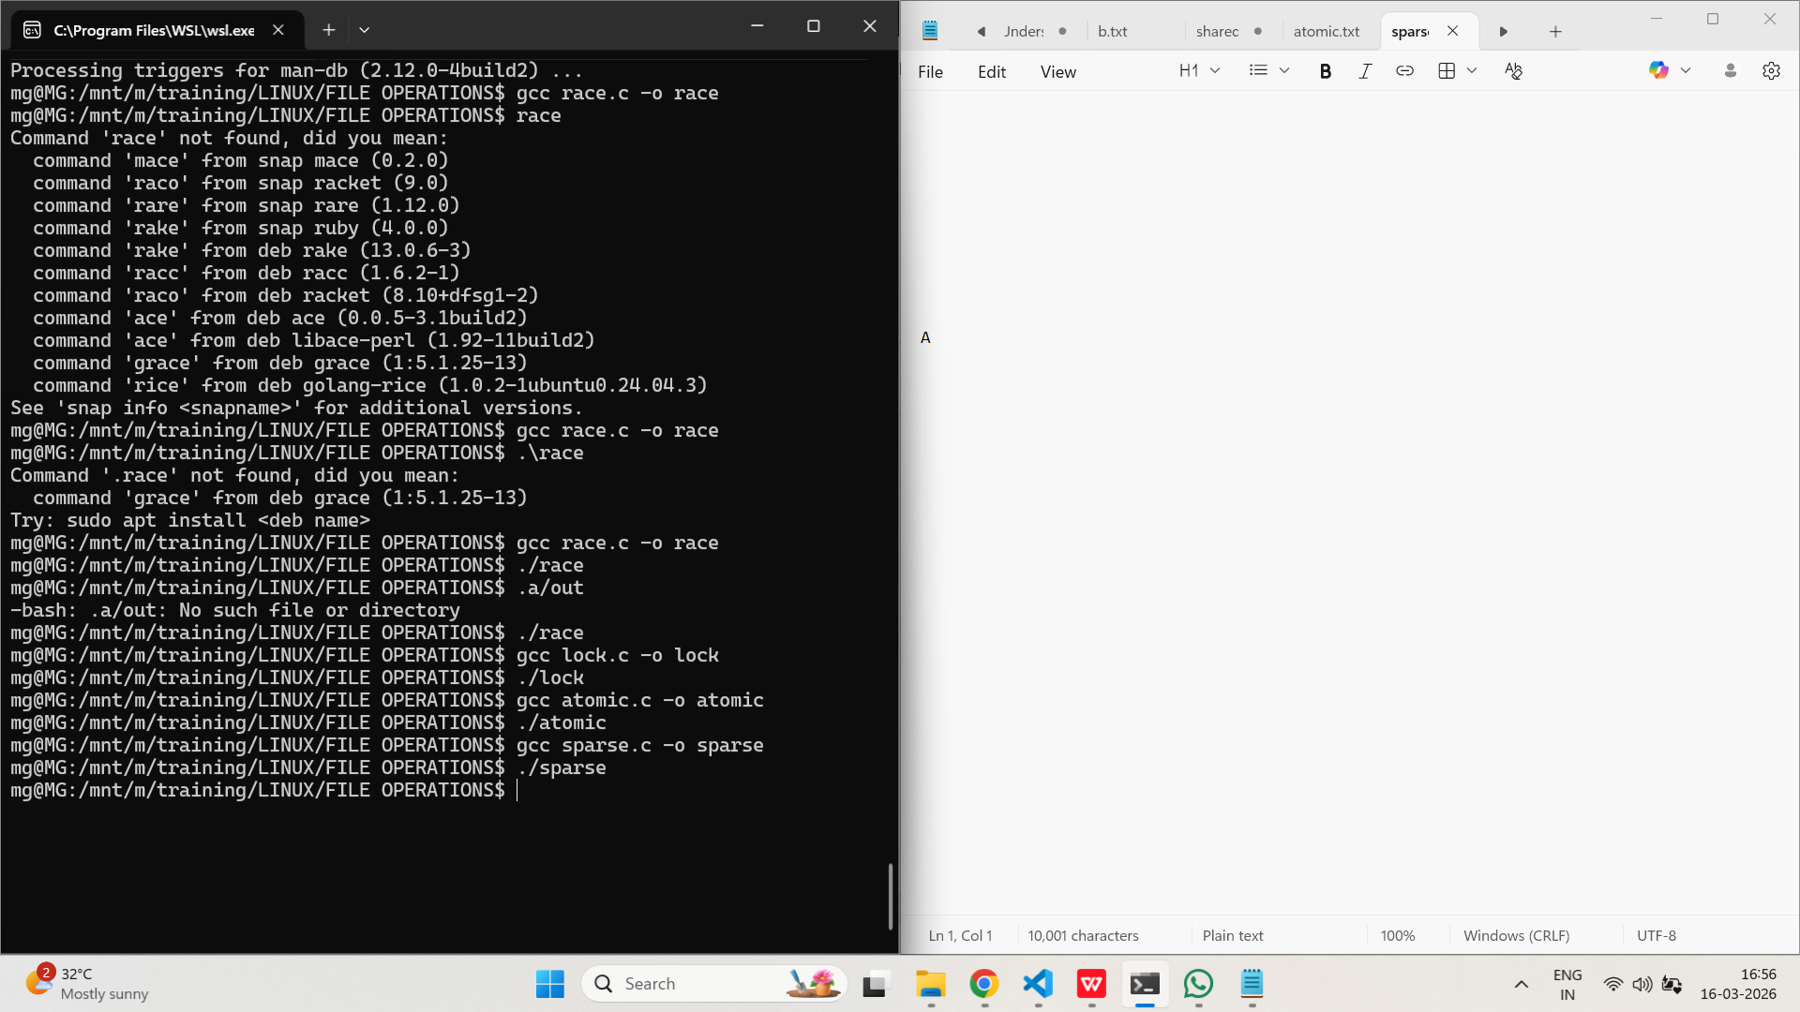

- Write a program that uses fcntl() to set a write lock on a region of a file. How do you handle lock contention between processes?
PROGRAM:
/*
Program to implement file locking
Author : MUTHUGANESH S
Date : 03/02/2026
Filename : flock.c
*/

//Header files
#include <stdio.h>
#include <unistd.h>
#include <fcntl.h>
#include <stdlib.h>

int main()
{
int fd;
struct flock lock;

fd = open("data.txt", O_RDWR | O_CREAT, 0644);

if(fd < 0)
{
perror("open");
exit(1);
}

lock.l_type = F_WRLCK;
lock.l_whence = SEEK_SET;
lock.l_start = 0;
lock.l_len = 50;
lock.l_pid = getpid();

printf("Process %d trying to acquire lock...\n", getpid());

if(fcntl(fd, F_SETLKW, &lock) == -1)
{
perror("fcntl");
exit(1);
}

printf("Lock acquired by process %d\n", getpid());
printf("Writing to file...\n");

write(fd, "Locked region write\n", 20);

sleep(10);

lock.l_type = F_UNLCK;
fcntl(fd, F_SETLK, &lock);

printf("Lock released by process %d\n", getpid());

close(fd);

return 0;
}
OUTPUT:
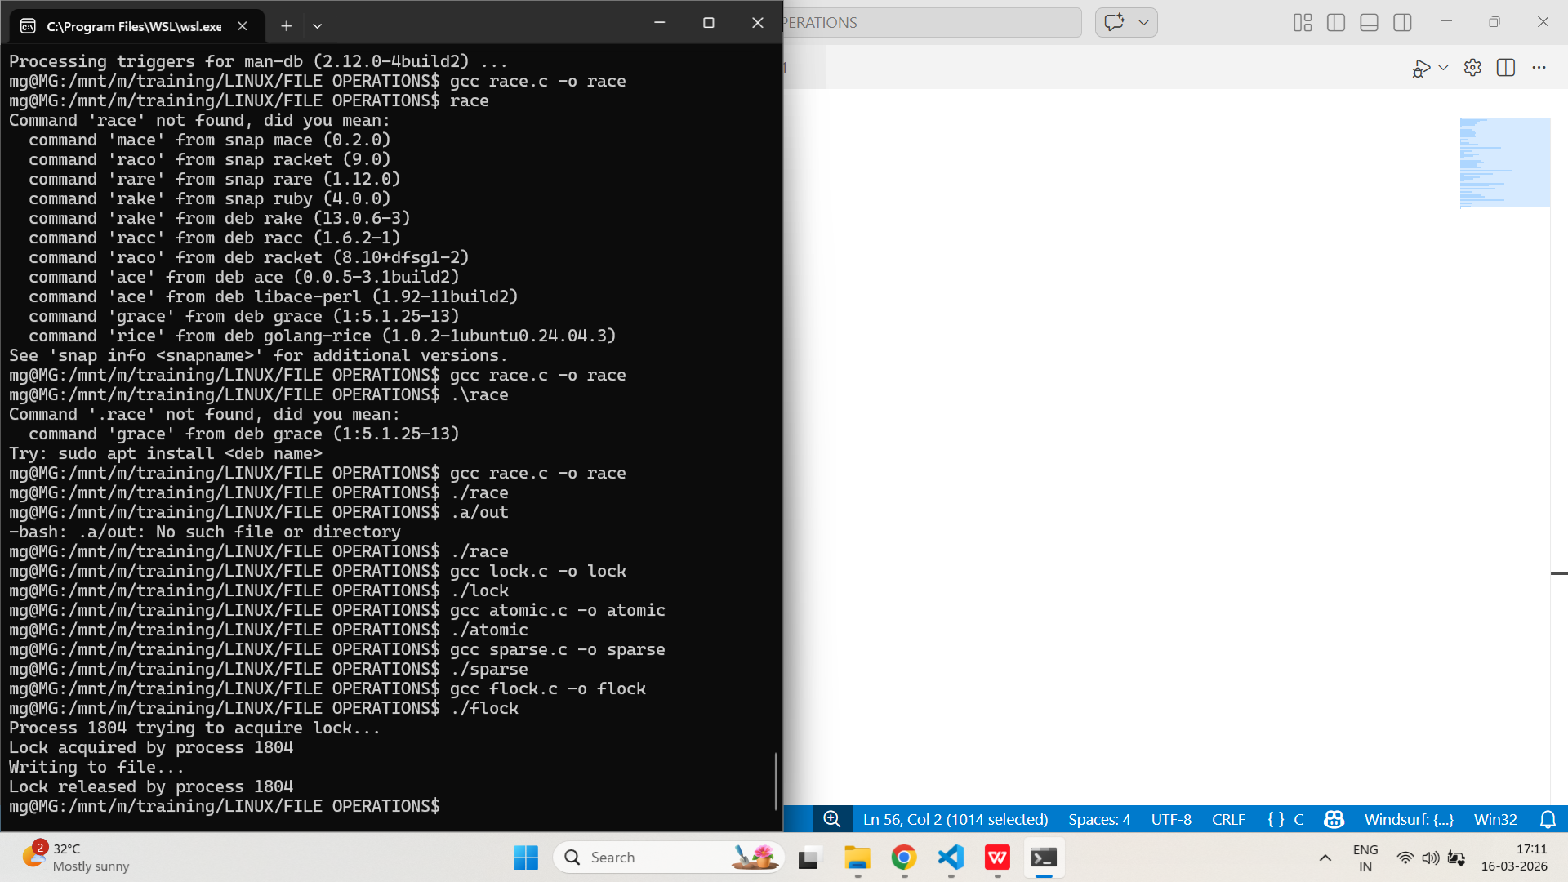
- Demonstrate how to use fcntl() to implement a read lock and a write lock, and explain the difference in behavior when multiple processes access the file.
PROGRAM:
/*
Program to read and write lock
Author : MUTHUGANESH S
Date : 03/02/2026
Filename : rwlock.c
*/

#include <stdio.h>
#include <unistd.h>
#include <fcntl.h>
#include <stdlib.h>

int main()
{
int fd;
struct flock lock;

fd = open("data.txt", O_RDWR | O_CREAT, 0644);

if(fd < 0)
{
perror("open");
exit(1);
}

lock.l_type = F_WRLCK;
lock.l_whence = SEEK_SET;
lock.l_start = 0;
lock.l_len = 50;
lock.l_pid = getpid();

printf("Process %d trying to acquire lock...\n", getpid());

if(fcntl(fd, F_SETLKW, &lock) == -1)
{
perror("fcntl");
exit(1);
}

printf("Lock acquired by process %d\n", getpid());
printf("Writing to file...\n");

write(fd, "Locked region write\n", 20);

sleep(10);

lock.l_type = F_UNLCK;
fcntl(fd, F_SETLK, &lock);

printf("Lock released by process %d\n", getpid());

close(fd);

return 0;
}
OUTPUT:
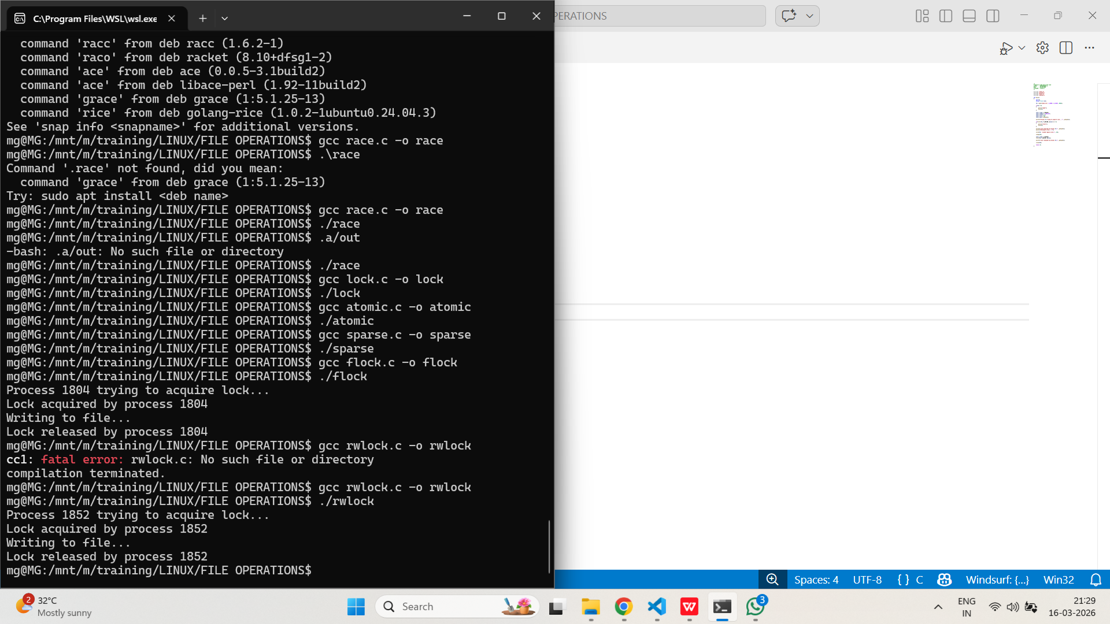

- Create a program that uses lseek() to read and write at random offsets in a file. How do you ensure data consistency?
PROGRAM:
/*
Program to read and write using lseek
Author : MUTHUGANESH S
Date : 03/02/2026
Filename : rwlseek.c
*/

//Header files
#include <stdio.h>
#include <unistd.h>
#include <fcntl.h>
#include <stdlib.h>
#include <string.h>

int main()
{
int fd;
char buffer[50];

fd = open("random.txt", O_RDWR | O_CREAT, 0644);

if(fd < 0)
{
perror("open");
exit(1);
}

strcpy(buffer, "HELLO");

lseek(fd, 10, SEEK_SET);
write(fd, buffer, strlen(buffer));

lseek(fd, 30, SEEK_SET);
write(fd, "LINUX", 5);

lseek(fd, 10, SEEK_SET);
read(fd, buffer, 5);
buffer[5] = '\0';

printf("Data at offset 10: %s\n", buffer);

lseek(fd, 30, SEEK_SET);
read(fd, buffer, 5);
buffer[5] = '\0';

printf("Data at offset 30: %s\n", buffer);

close(fd);

return 0;
}
OUTPUT:
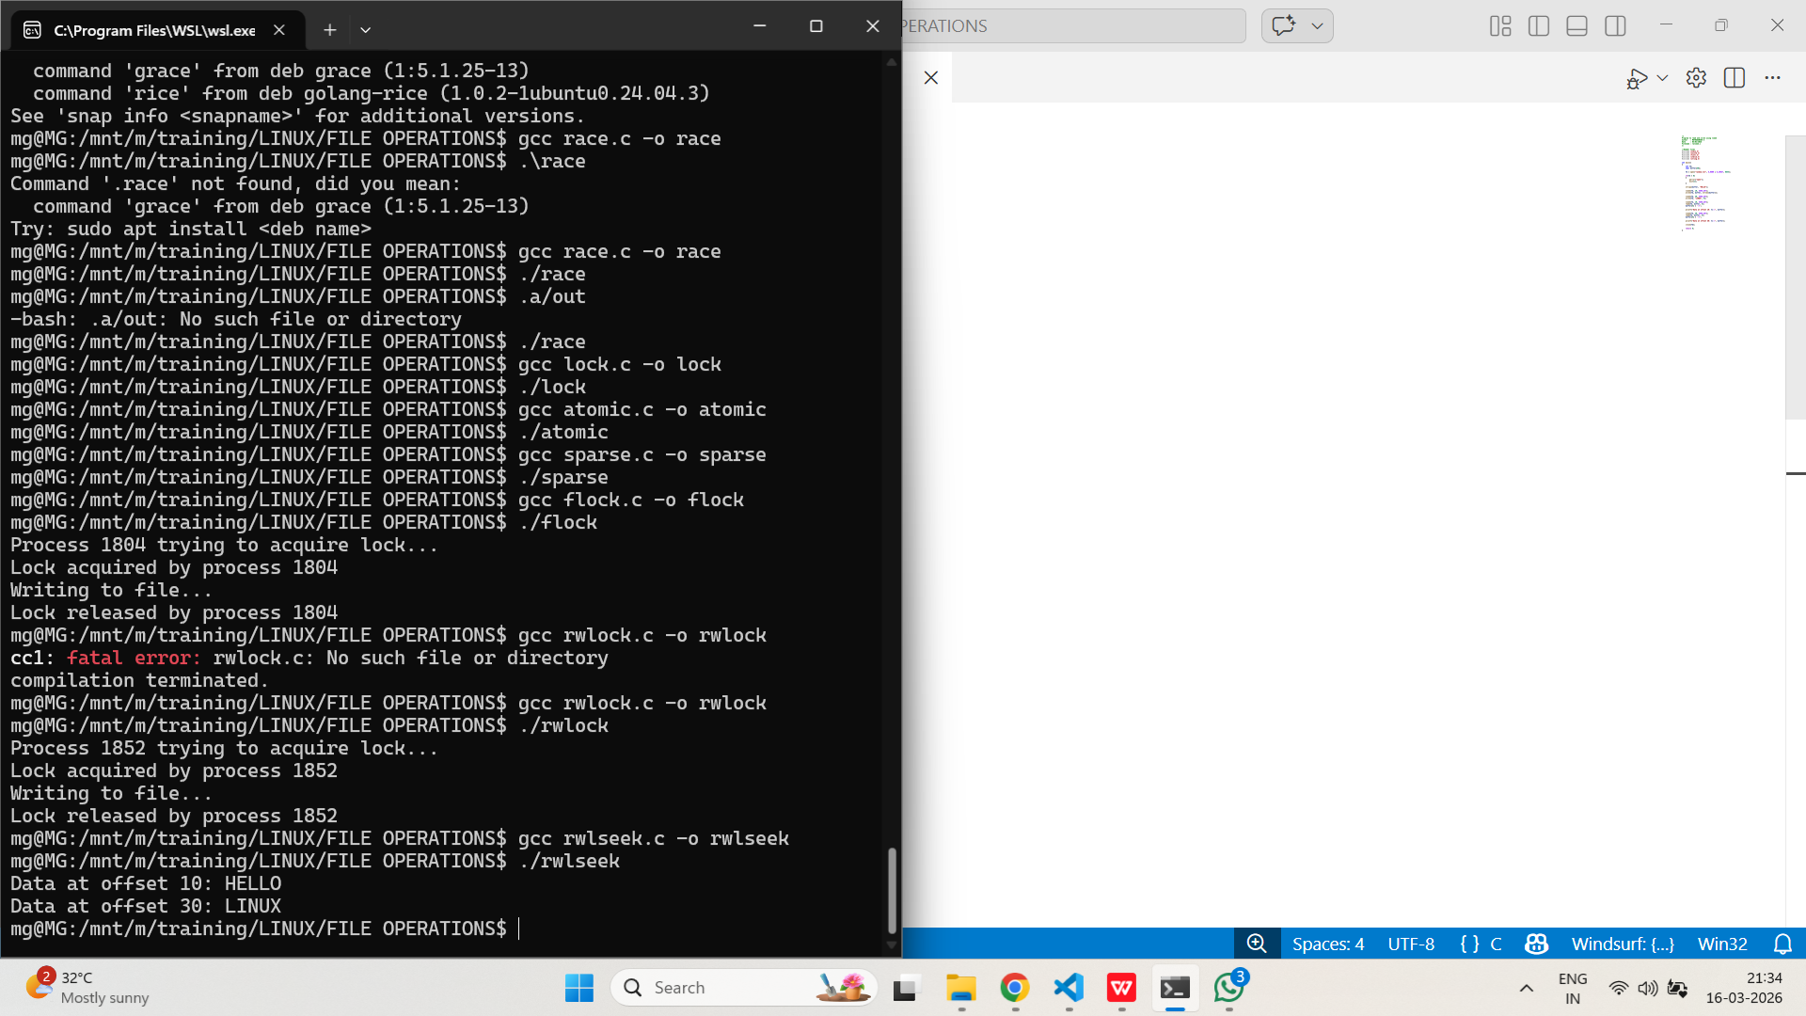
- Write a C program that uses advisory file locking (fcntl) to synchronize access between a parent and child process. What happens if one process ignores the lock?
PROGRAM:
/*
Program to implement parent child synchronization
Author : MUTHUGANESH S
Date : 03/02/2026
Filename : parent.c
*/

//Header files
#include <stdio.h>
#include <unistd.h>
#include <fcntl.h>
#include <stdlib.h>
#include <string.h>

void lock_file(int fd)
{
struct flock lock;

lock.l_type = F_WRLCK;
lock.l_whence = SEEK_SET;
lock.l_start = 0;
lock.l_len = 0;

printf("Process %d waiting for lock...\n", getpid());

fcntl(fd, F_SETLKW, &lock);

printf("Process %d acquired lock\n", getpid());
}

void unlock_file(int fd)
{
struct flock lock;

lock.l_type = F_UNLCK;
lock.l_whence = SEEK_SET;
lock.l_start = 0;
lock.l_len = 0;

fcntl(fd, F_SETLK, &lock);
}

int main()
{
int fd;
pid_t pid;

fd = open("sync.txt", O_RDWR | O_CREAT | O_APPEND, 0644);

if(fd < 0)
{
perror("open");
exit(1);
}

pid = fork();

lock_file(fd);

if(pid == 0)
{
write(fd, "Child writing to file\n", 22);
sleep(3);
}
else
{
write(fd, "Parent writing to file\n", 23);
sleep(3);
}

unlock_file(fd);

printf("Process %d released lock\n", getpid());

close(fd);

return 0;
}
OUTPUT:
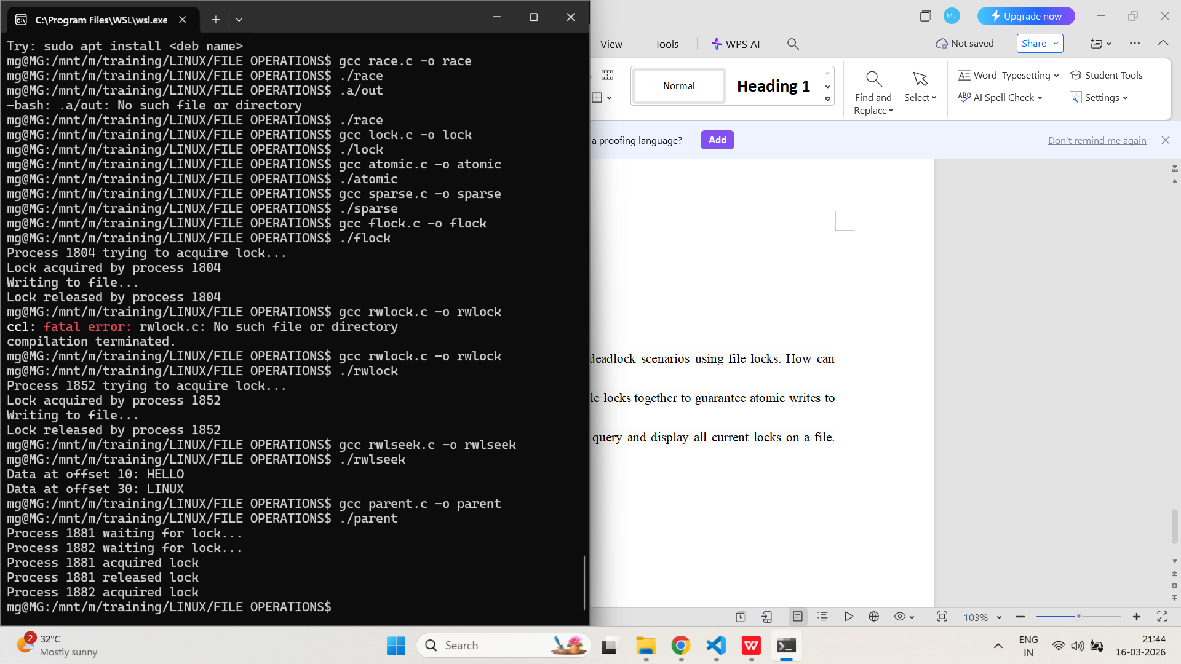
- Implement a program that tests for deadlock scenarios using file locks. How can you detect and resolve deadlocks?
PROGRAM:
/*
Program to implement deadlock
Author : MUTHUGANESH S
Date : 03/02/2026
Filename : deadlock.c
*/

//Header files
#include <stdio.h>
#include <unistd.h>
#include <fcntl.h>
#include <stdlib.h>

void lock_region(int fd, int start)
{
struct flock lock;

lock.l_type = F_WRLCK;
lock.l_whence = SEEK_SET;
lock.l_start = start;
lock.l_len = 10;

printf("Process %d trying to lock region starting at %d\n", getpid(), start);

if(fcntl(fd, F_SETLKW, &lock) == -1)
{
perror("fcntl");
exit(1);
}

printf("Process %d locked region %d\n", getpid(), start);
}

//Function to unlock a region
void unlock_region(int fd, int start)
{
struct flock lock;

lock.l_type = F_UNLCK;
lock.l_whence = SEEK_SET;
lock.l_start = start;
lock.l_len = 10;

fcntl(fd, F_SETLK, &lock);
}

//Main function
int main()
{
int fd;
pid_t pid;

fd = open("deadlock.txt", O_RDWR | O_CREAT, 0644);

if(fd < 0)
{
perror("open");
exit(1);
}

pid = fork();

if(pid == 0)
{
lock_region(fd, 0);
sleep(2);

lock_region(fd, 20);

unlock_region(fd, 20);
unlock_region(fd, 0);
}
else
{
lock_region(fd, 20);
sleep(2);

lock_region(fd, 0);

unlock_region(fd, 0);
unlock_region(fd, 20);
}

close(fd);
return 0;
}
OUTPUT:
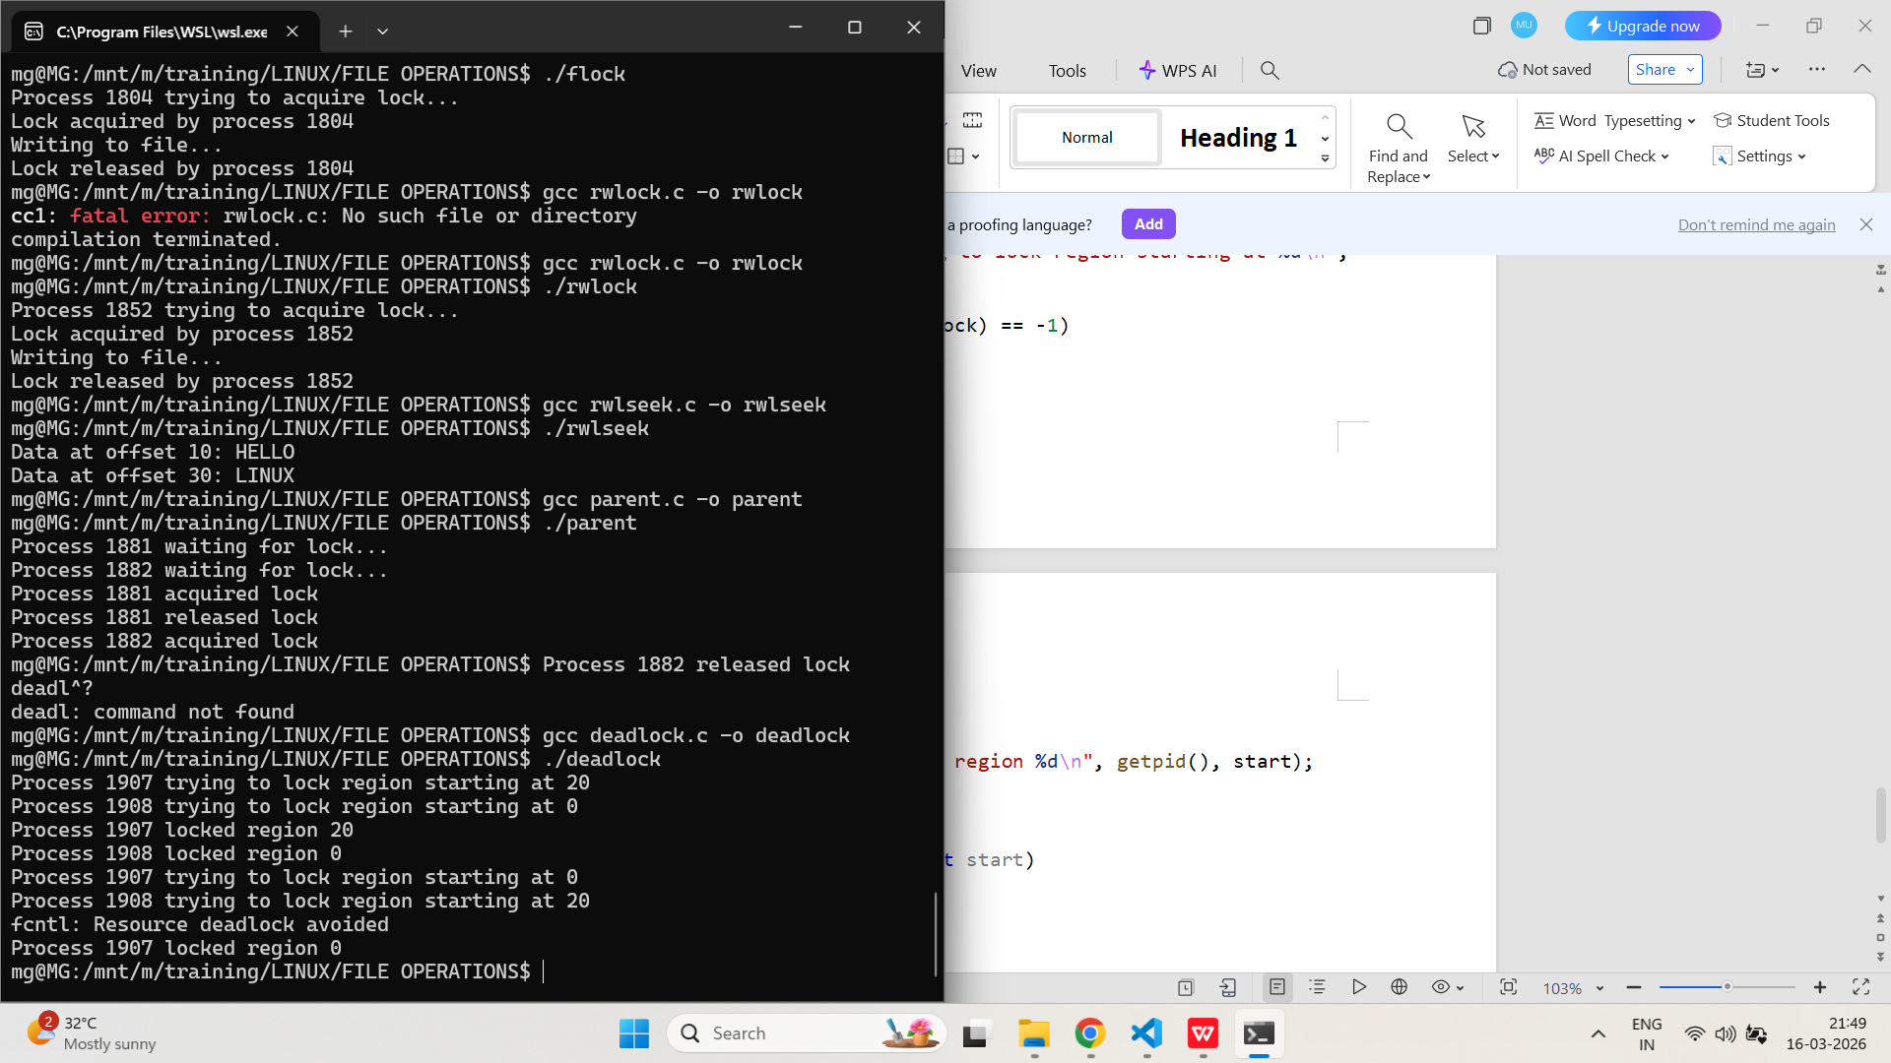
- Show how to use O_APPEND and file locks together to guarantee atomic writes to a log file from multiple processes.
PROGRAM:
/*
Program to append log entries to a file
Author : MUTHUGANESH S
Date : 03/02/2026
Filename : logfile.c
*/

//Header files
#include <stdio.h>
#include <unistd.h>
#include <fcntl.h>
#include <stdlib.h>
#include <string.h>
#include <time.h>

//Function declaration
void lock_file(int fd)
{
struct flock lock;

lock.l_type = F_WRLCK;
lock.l_whence = SEEK_SET;
lock.l_start = 0;
lock.l_len = 0;

fcntl(fd, F_SETLKW, &lock);
}

//Function declaration
void unlock_file(int fd)
{
struct flock lock;

lock.l_type = F_UNLCK;
lock.l_whence = SEEK_SET;
lock.l_start = 0;
lock.l_len = 0;

fcntl(fd, F_SETLK, &lock);
}

//Main function
int main()
{
int fd;
pid_t pid;
char buffer[200];
time_t now;

fd = open("logfile.txt", O_WRONLY | O_CREAT | O_APPEND, 0644);

if(fd < 0)
{
perror("open");
exit(1);
}

pid = fork();

for(int i = 0; i < 5; i++)
{
lock_file(fd);

now = time(NULL);

if(pid == 0)
sprintf(buffer, "Child PID %d: log entry at %ld\n", getpid(), now);
else
sprintf(buffer, "Parent PID %d: log entry at %ld\n", getpid(), now);
write(fd, buffer, strlen(buffer));
unlock_file(fd);
sleep(1);
}
close(fd);
return 0;
}
OUTPUT:
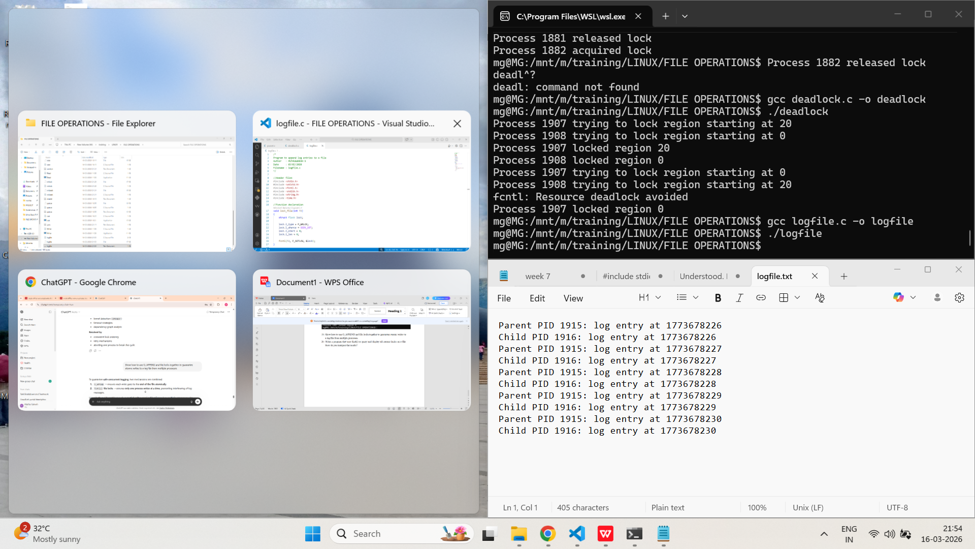
- Write a program that uses fcntl() to query and display all current locks on a file. How do you interpret the results?
PROGRAM:
/*
Program to check if a file is locked
Author : MUTHUGANESH S
Date : 03/02/2026
Filename : checklock.c
*/

//Header files
#include <stdio.h>
#include <unistd.h>
#include <fcntl.h>
#include <stdlib.h>
int main()
{
int fd;
struct flock lock;
fd = open("lockfile.txt", O_RDWR | O_CREAT, 0644);
if(fd < 0)
{
perror("open");
exit(1);
}
lock.l_type = F_WRLCK;
lock.l_whence = SEEK_SET;
lock.l_start = 0;
lock.l_len = 0;
if(fcntl(fd, F_GETLK, &lock) == -1)
{
perror("fcntl");
close(fd);
exit(1);
}
if(lock.l_type == F_UNLCK)
{
printf("No locks currently prevent this lock request.\n");
}
else
{
printf("Lock detected:\n");
printf("Process ID holding lock: %d\n", lock.l_pid);

if(lock.l_type == F_RDLCK)
printf("Lock type: READ LOCK\n");
else if(lock.l_type == F_WRLCK)
printf("Lock type: WRITE LOCK\n");

printf("Start offset: %ld\n", lock.l_start);
printf("Length: %ld\n", lock.l_len);
}
close(fd);
return 0;
}

OUTPUT:

